Medical Laboratory System Database Project Report

- Project Overview
The Medical Laboratory System (MLS) database is designed to efficiently manage all operational aspects of a medical laboratory. This comprehensive system tracks patient information, laboratory staff, medical tests, testing components, and test results while supporting essential business queries and reporting functions.

Table | columns | PK/FK
Laboratorian | LaboratorianID, Name, Phone, Address | PK: LaboratorianID
Patient | PatientID, Name, Phone, Address, BirthDate, Job | PK: PatientID
component | ComponentID, Name, AvailableQuantity, MinimumQuantity | PK: ComponentID
MedicalTest | TestID, Name, Price | PK: TestID
TestResult | TestID, Date, PatientID, LaboratorianID, Result | PK: (TestID, Date)  FK: TestID, PatientID, LaboratorianID
- Conceptual list (Attributes&Entities):

  - Entities & Attributes Analysis
The database organizes information into six Attributes:
- Laboratorian
- Role: Performs medical tests and records results.
- Attributes:
- LabID (Primary Key): Unique identifier for each lab technician.
- Name: Full name of the laboratorian.
- PhoneNumber: Contact information.
- Address: Residential or work address.
- Patient
- Role: Individual undergoing medical tests.
- Attributes:
- PatientID (Primary Key): Unique identifier.
- Name: Full name.
- PhoneNumber: Contact details.
- Address: Home address.
- BirthDate: For age-related medical assessments.
- Job: Occupation (may influence test requirements).

- Component (Lab Materials):
- Role: Reagents, chemicals, and materials used in tests.
- Attributes:
- ComponentID (Primary Key): Unique identifier.
- Name: Description of the component (e.g., "Glucose Reagent").
- AvailableQty: Current stock level.
- MinimumQty: Threshold triggering restocking alerts.

- Medical Test:
- Role: Defines different types of tests offered.
- Attributes:
- TestID (Primary Key): Unique identifier.
- Name: Test name (e.g., "Complete Blood Count (CBC)").
- Price: Cost of the test.

- Test Result:
- Role: Records the outcome of a test.
- Attributes:
- ResultID (Primary Key): Auto-incremented unique identifier.
- TestID (Foreign Key): Links to the MedicalTest table.
- PatientID (Foreign Key): Links to the Patient table.
- LabID (Foreign Key): Identifies the laboratorian who conducted the test.
- Date: When the test was performed.
- Result: Detailed outcome (e.g., numerical values, observations).

4. ER Diagram description
1. Laboratorian-Performs-TestResult (One-to-Many):
- One laboratorian can perform multiple test results.
2. Patient-Has-TestResult (One-to-Many):
- A patient can have multiple test results.
3. MedicalTest-Uses-Component (Many-to-Many):
- A test may require multiple components, and a component may be used in multiple tests.

4.1.Cardinality & Participation Constraints:
Total Participation:
Every TestResult must link to one Patient, one Laboratorian, and one MedicalTest.
Partial Participation:
- Components may not be associated with any test.

5. DDL & DML

5.1.DDL (SQL Script)
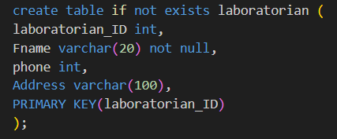
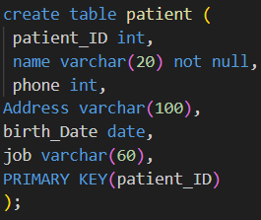

5.2.DML (Sample Queries)

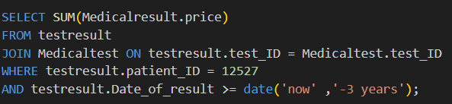
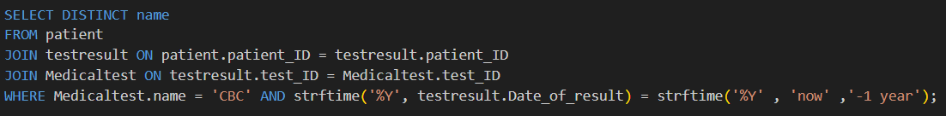

6. Test Data
Sample Rows
- Laboratorian Table:

| 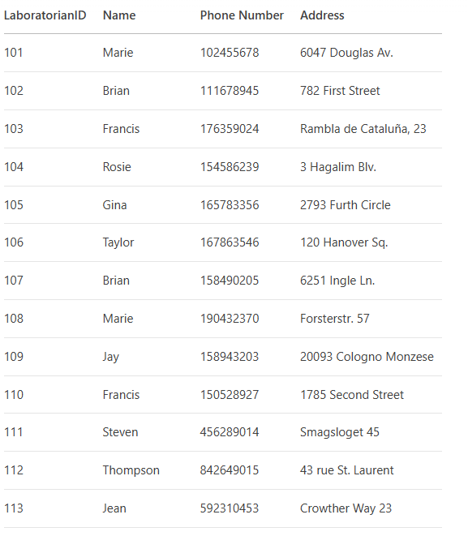

- Patient table

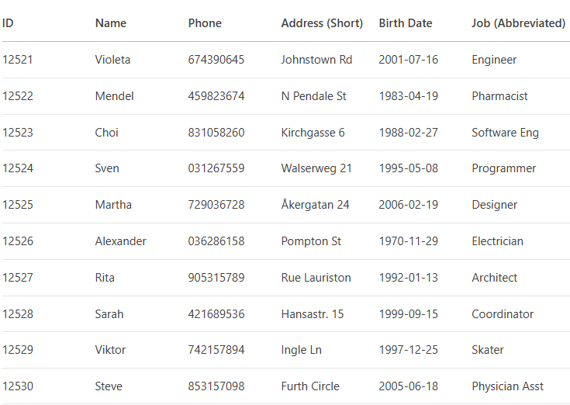

7. Conclusion
- This Medical Laboratory System Database is designed to:
- Improve efficiency in test tracking and reporting.
- Ensure data accuracy with strict relational integrity.
- Support decision-making* through advanced queries.

